Welcome to Fluxx
- Getting Started

Step 1. Go to the United Way SELA Fluxx website at https://unitedwaysela.fluxx.io/

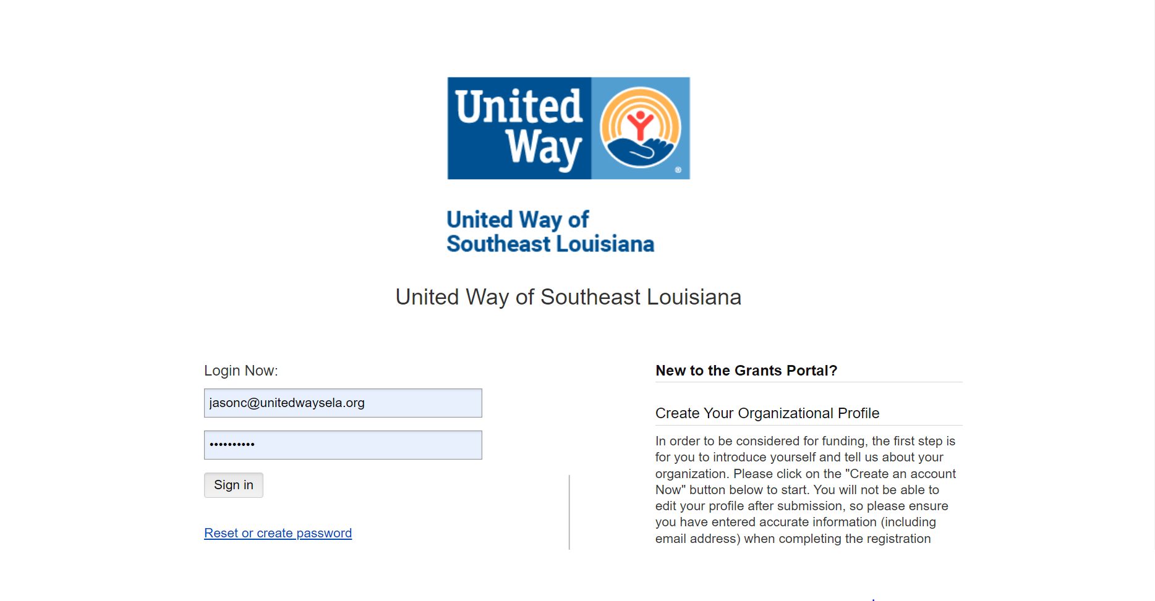

If this is your fist visit to Fluxx, you’ll need to create your organization’s profile.

Step 2. Click ‘Create an account now’
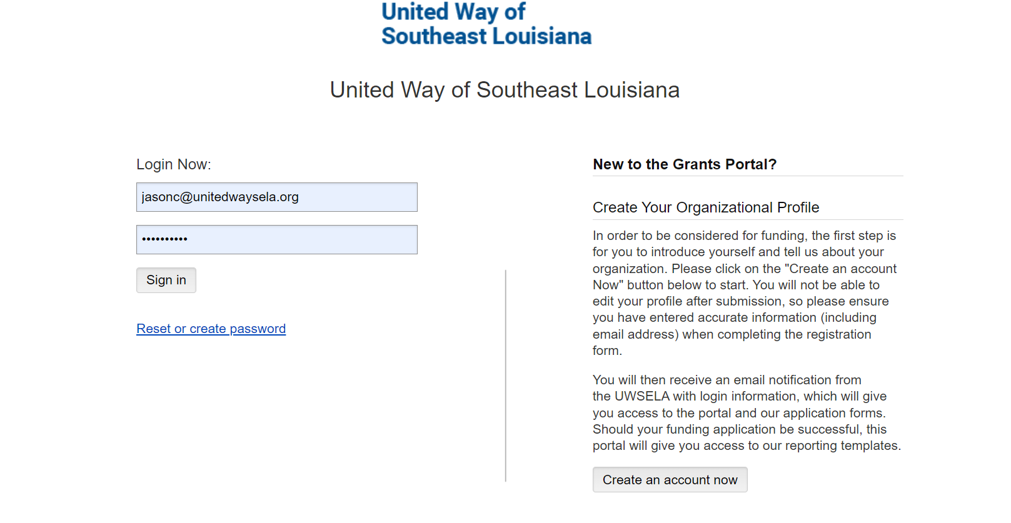
Step 3. Take the Eligibility Quiz. 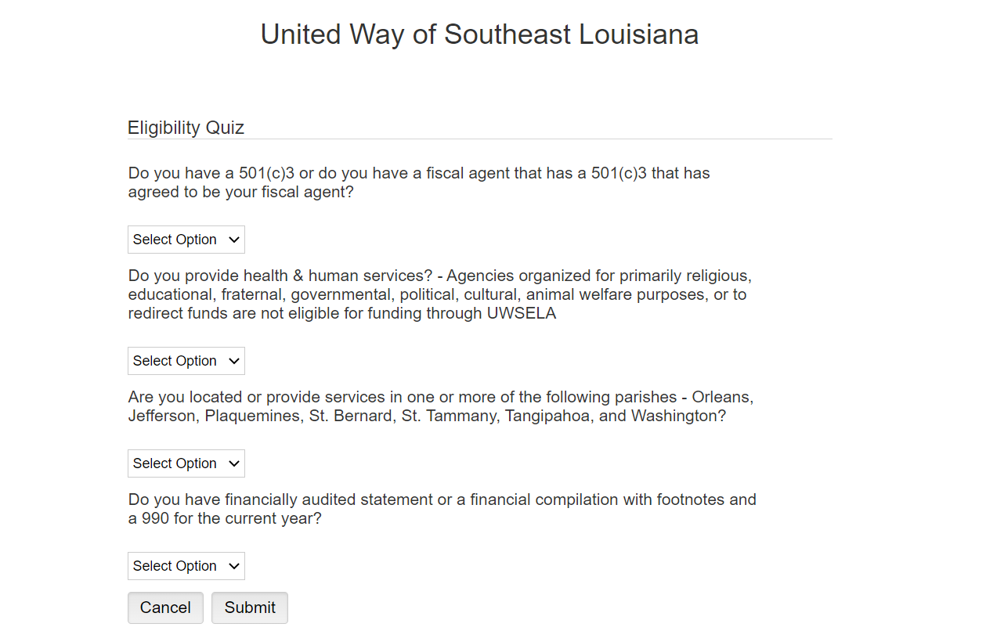

Once you have passed the Eligibility Quiz, you will be prompted to create your organizational profile.

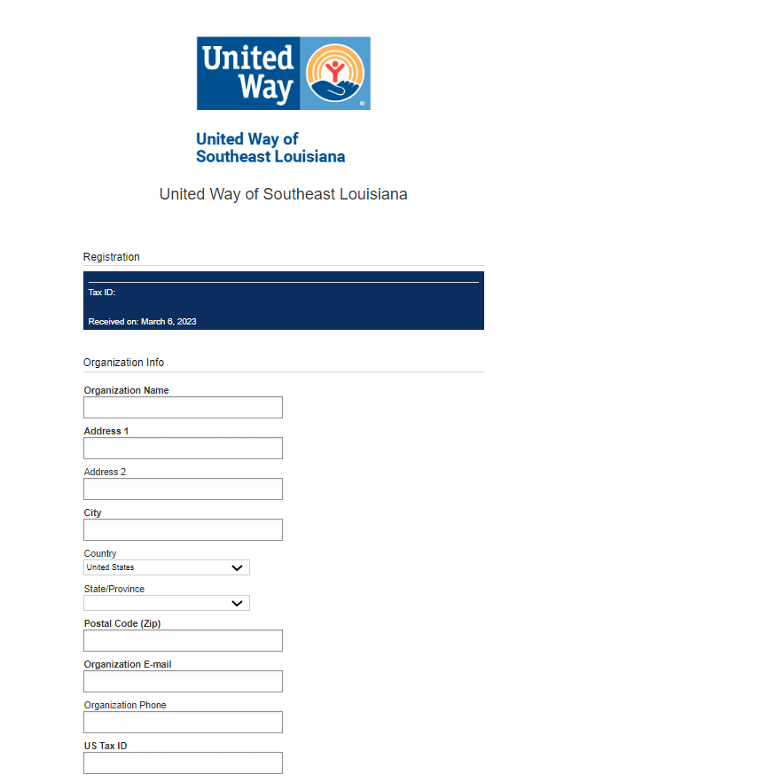

Step 4. Register your organization by completing the ‘Organization Info’ and ‘Primary Contact Info.’
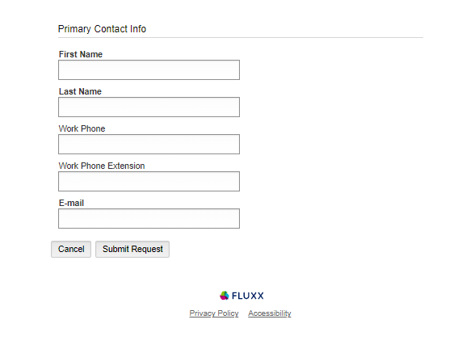

Step 5. Click ‘Submit Request.’

That’s it! You’ve just registered your organization in Fluxx. Once the request is received, reviewed and approved, you’ll receive an email with login information and the next steps to submit a grant request.

